1. Sources Code

Web.php🡪controller

web_header.php🡪view

web_index.php🡪view

web_footer.php🡪view

stylebuku.css🡪assets🡪css1

2. URL

<http://localhost/pustaka_ajeng/Web>

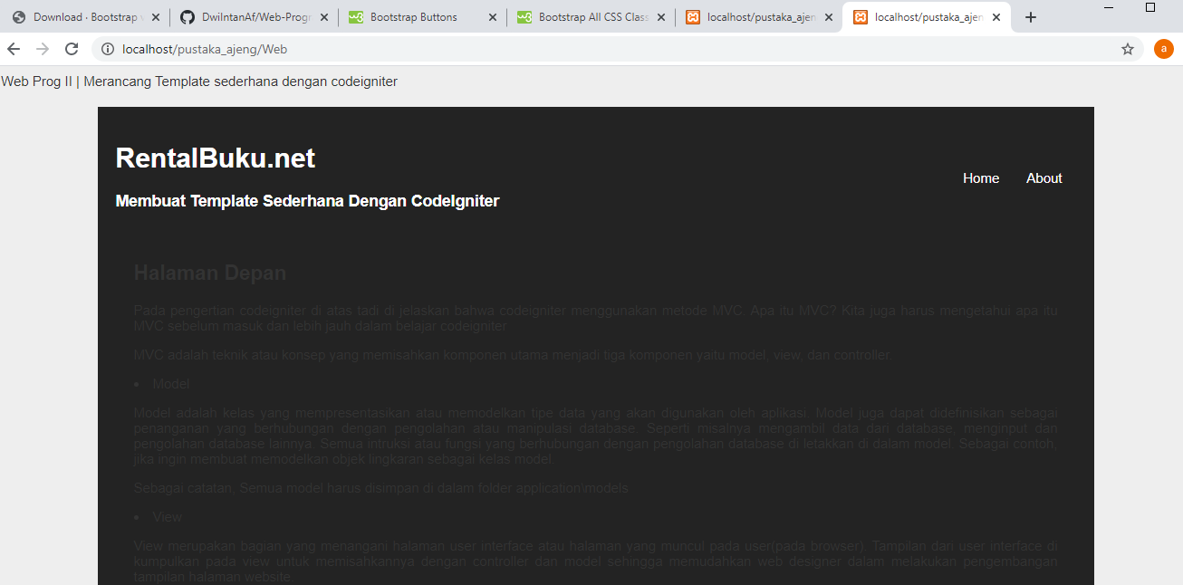3. Capture Output Program